**Glitterlab Mathine Task Assignment**

1. Software Introduction:-

This is web based Application. Which shows Total summary of Students Details in graphical representation using pie chart and line chart. This Application is divided into three different modules which is Login Page ,Dashboard, and total Time Summary which is displayed in graphical representation.

**2) Hardware and software Requirments**

1)Hardware Requirment

Min. Ram : 512 mb

Min. Hard Disk : 250 GB

Processor :- p4 and above

**2) software Requirement**

**i)** **System Specification**

1) Operating system :- windows,linux,unix etc.

2)Browser(Client):- Chrome(latest),mozila,opera etc.

**ii)Deployment Software Requirment.**

1)JDK/JRE(1.7 and above)

2)MY-SQL

3)Server(Apache Tomcate 7.0)

iii)Development Software Requirmnts

i)IDE :- Eclipse / STS Bundle

IT’s a web based software application which is run on server if user wants to purchase domain name hosting then it’s deployed on server basically it’s support linux based servers . it’s also support windows based server but need to request to service provider in plesk panel to add java application.

3)**Technology Used**

i)Front End Technology

i)Spring Framwork(MVC)

II) Jsp/HTML Pges

iii)Core Java / Adv. Java

iv)Bootstrap (Admin Template)

v)Jquery

ii) Back end Technology(Database)

i)My-sql

Application Snapshots : -

User Name:- admin

Password :- admin

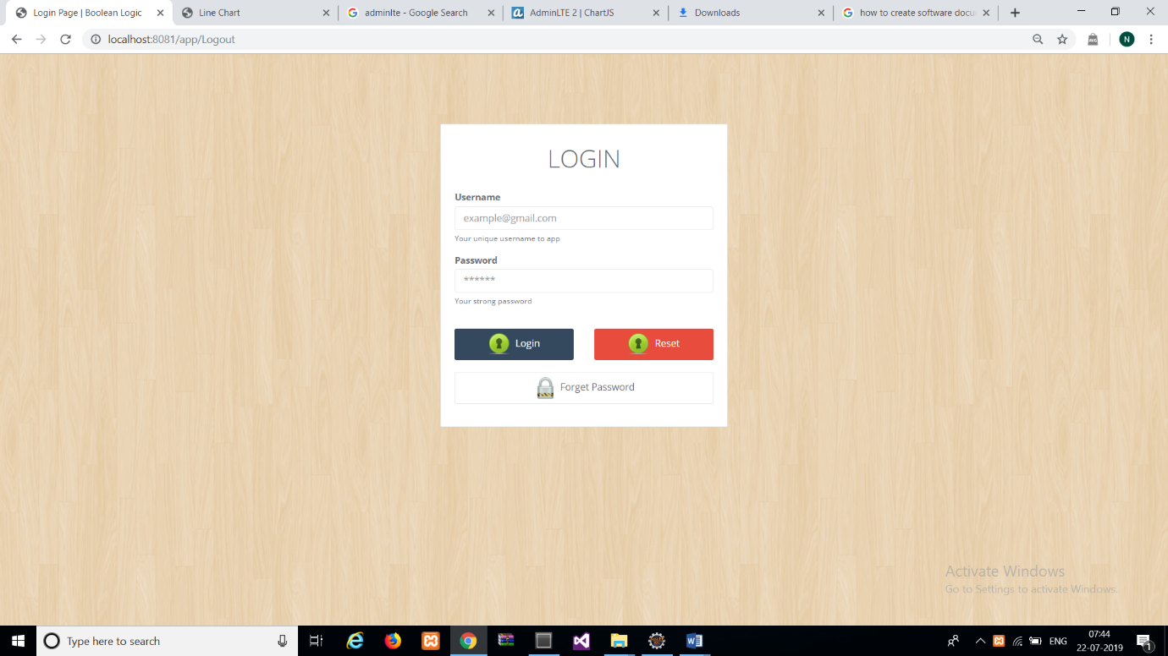

1. Dashboard

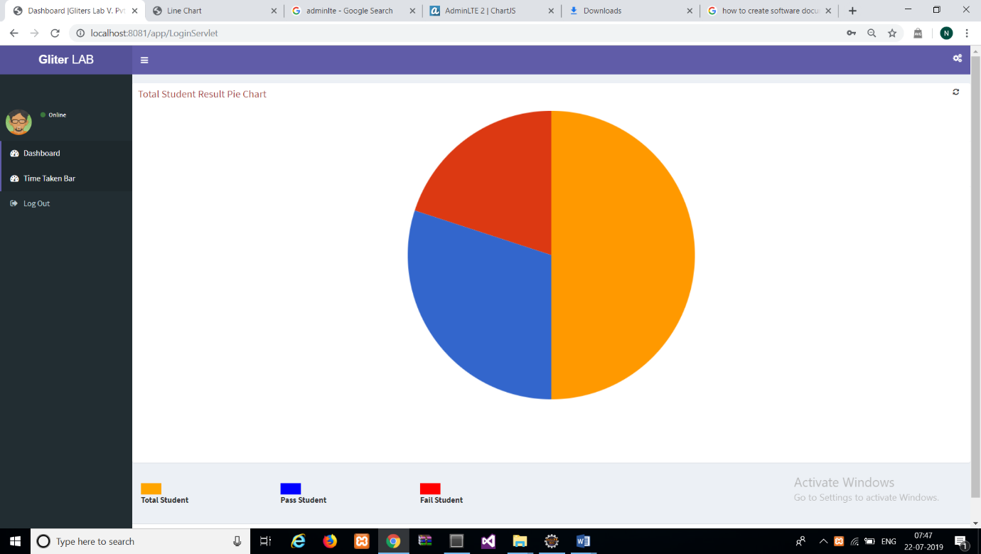

1. list of components and time taken by each component.

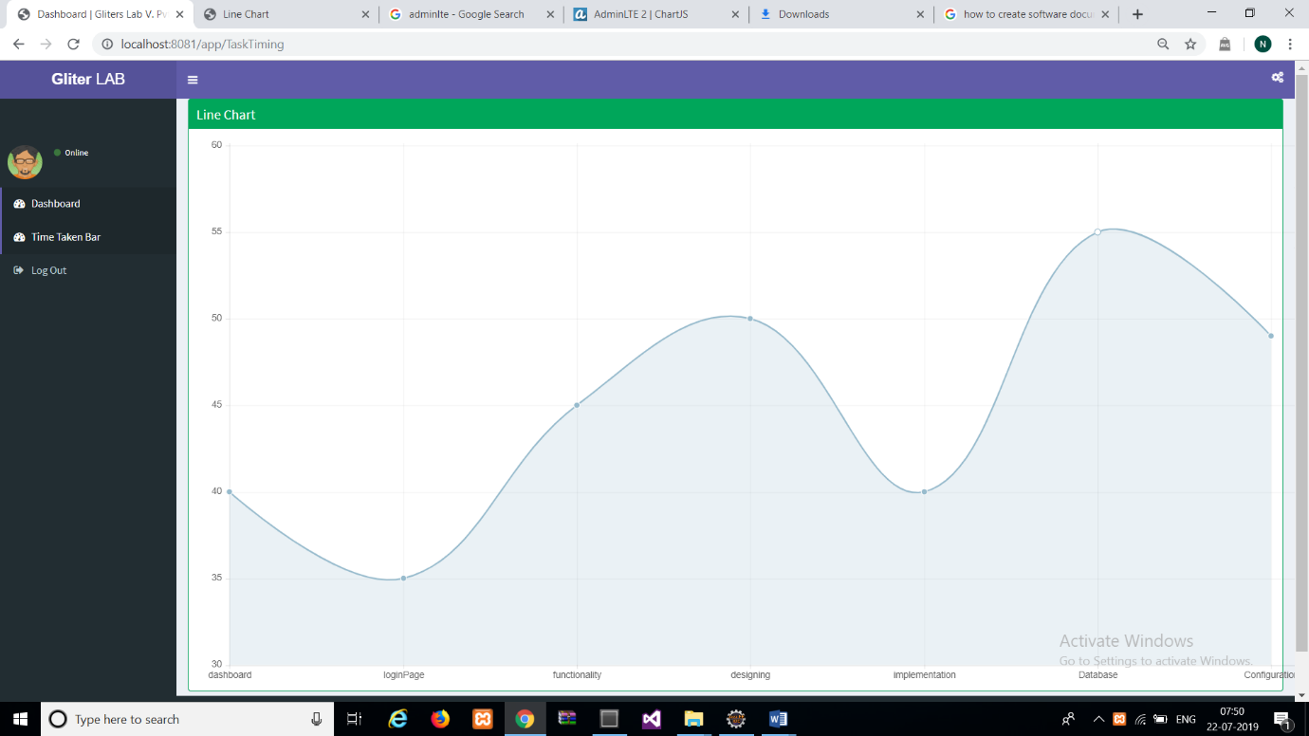

1. logout

1. Database Designing :-

DB Name : - gliterdb

**Tables** : -

1. student_mark
2. student_registraion

1) student_registraion

|  |  |
| --- | --- |
| **Data Type** | **Columns Name** |
| Int (Primary Key) | Stu_id |
| Varchar(100) | stu_name |
| text | stu_address |
| text | stu_standerd |
| date | stu_start_session |
| date | stu_end_session |

2) student_mark

|  |  |
| --- | --- |
| **Data Type** | **Columns Name** |
| Int (Primary Key) auto_increment | id |
| Int | Stu_id |
| Int | Maths |
| Int | Sci |
| Int | History |
| int | English |

Views :

1. getstudentinfo
2. getstudentinfo
3. getstudentresult